Assignment 10- Treemaps
Course: 6380.003
Name: Anamika Das
Net ID: axd240045

1.
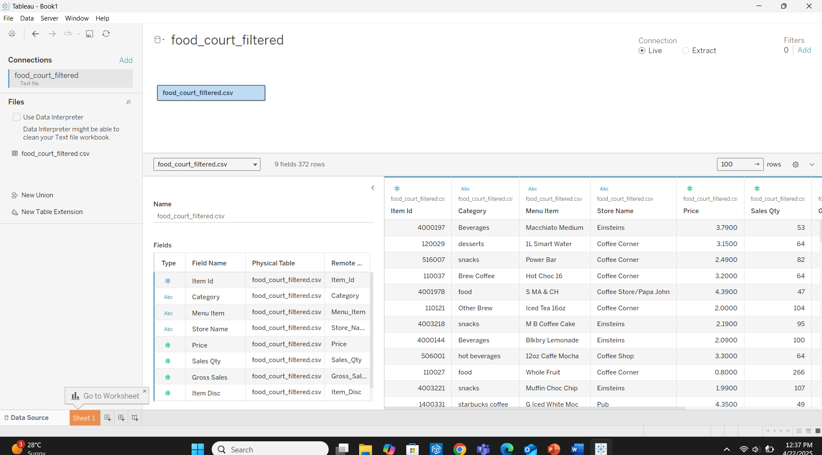
2.
9 columns and 372 rows
3.
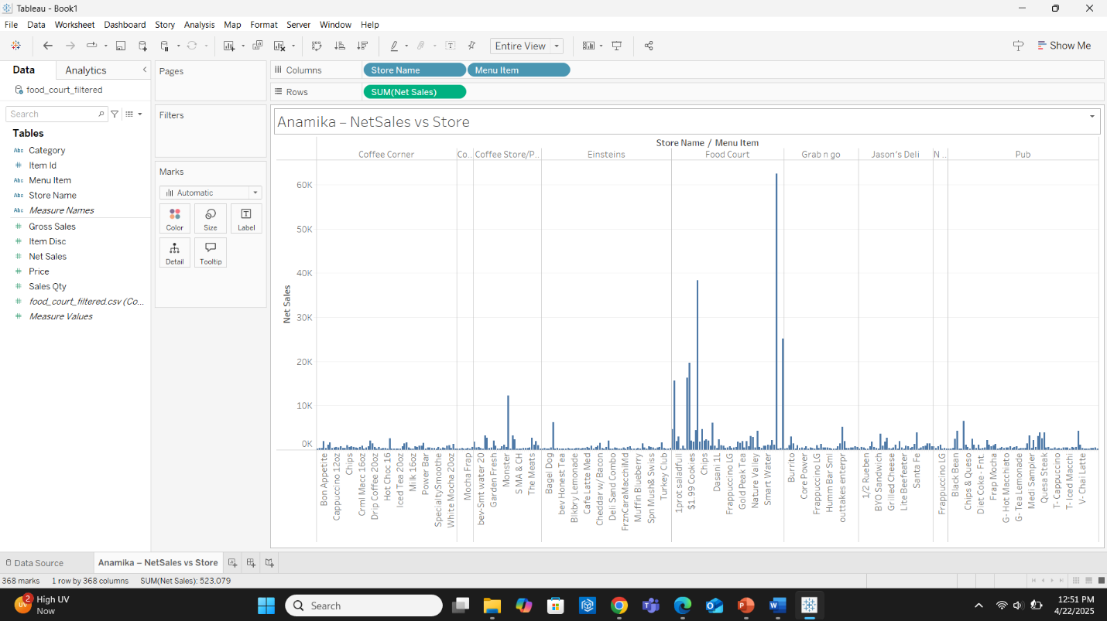
4.
This is a Vertical Bar Chart (also called Column Chart)

5.
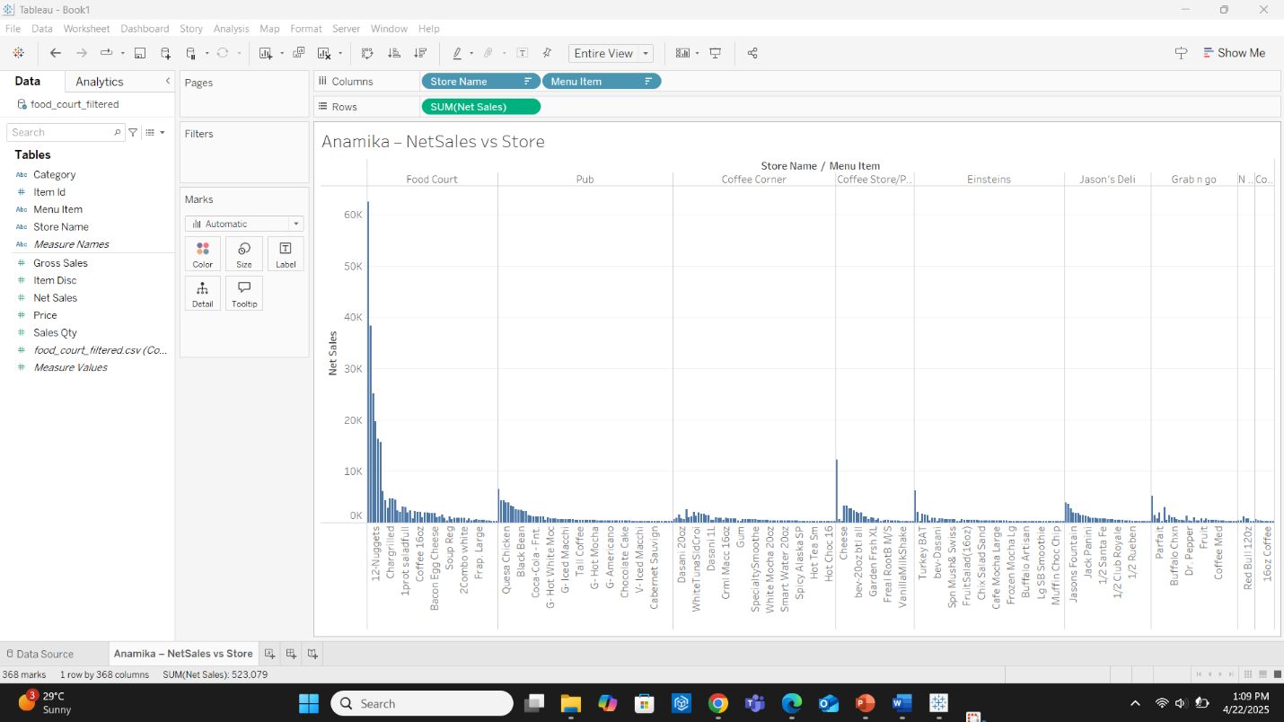

6.
Net sale value: 375

7.
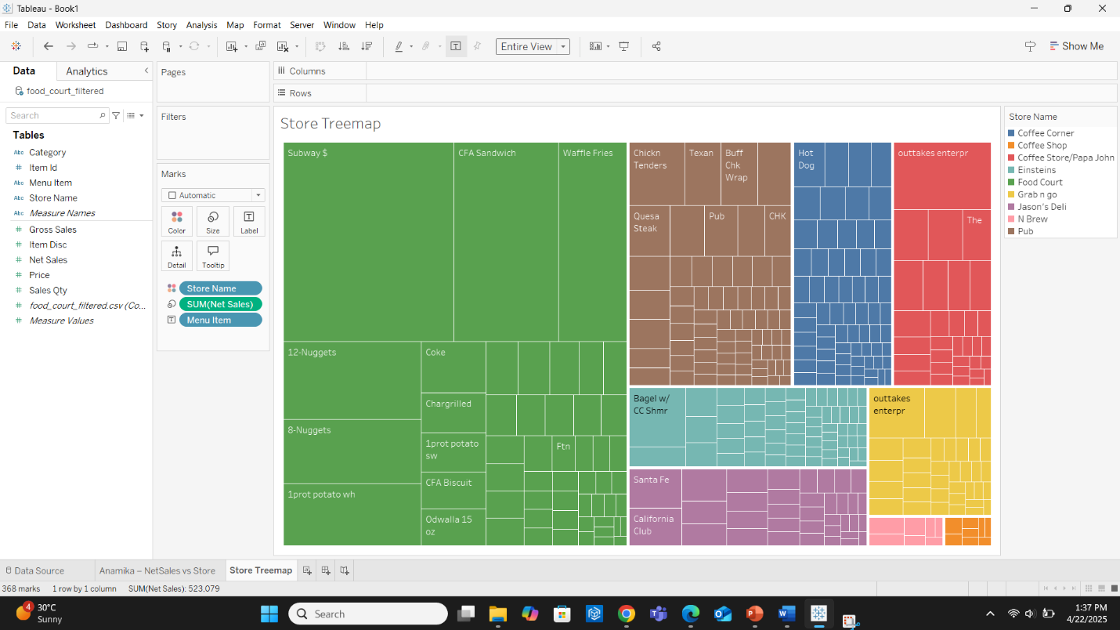
8.
The food court (Subway) store appears to have the largest net sales.
9.
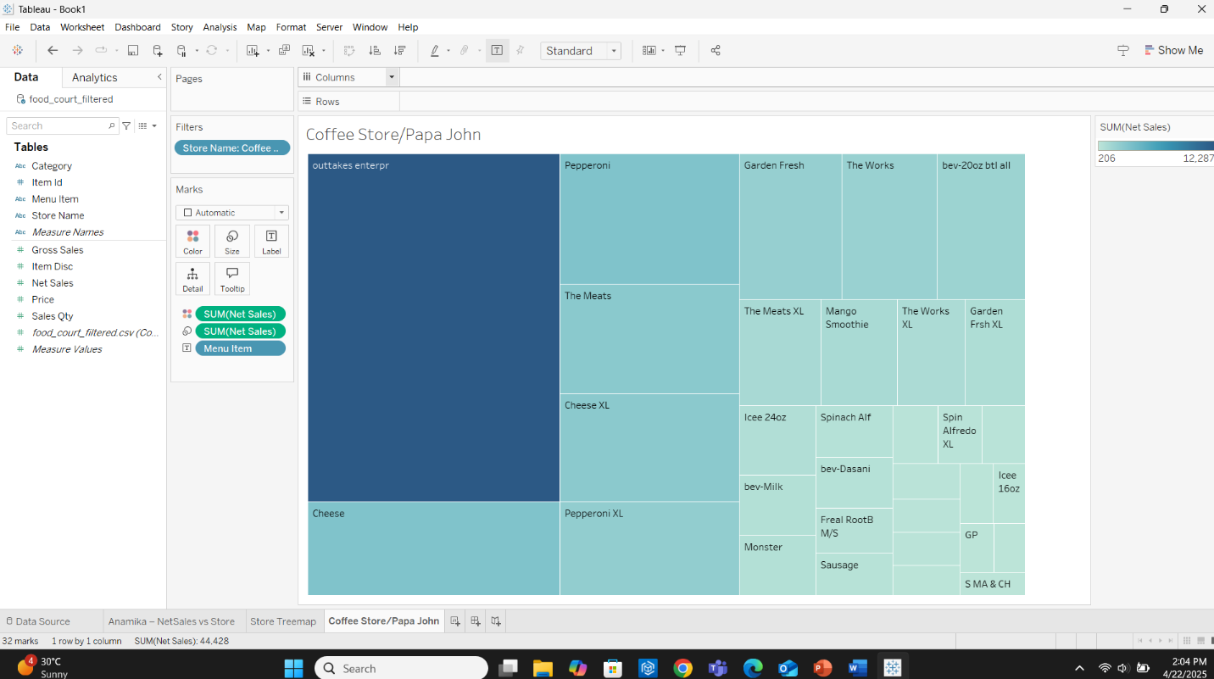
10. Net sales: 548
11.
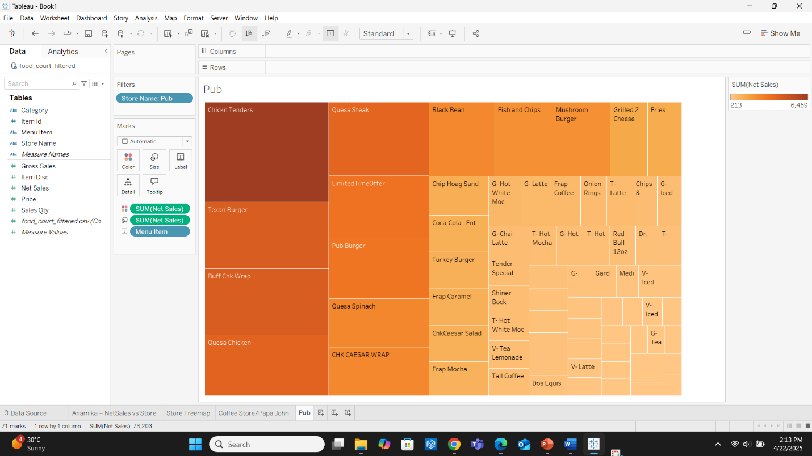
12. Net sales: 571
13.
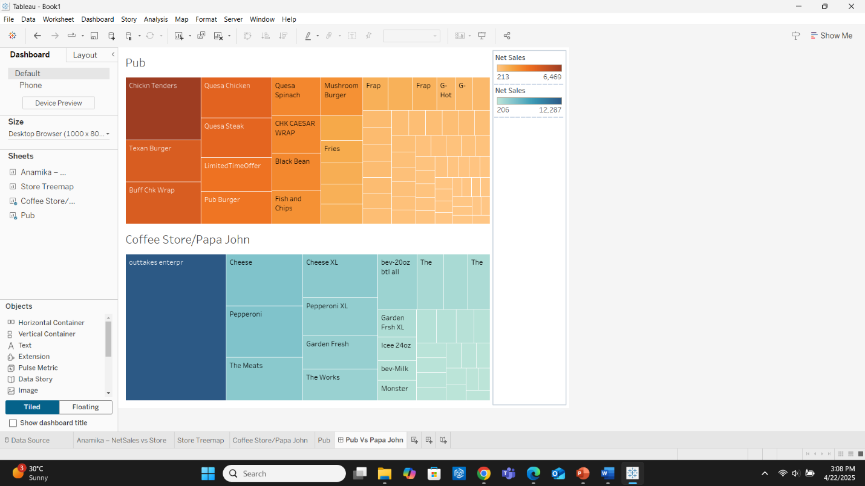
14.
The comparison from the treemaps:
- Texan Burger (under Pub)
  - Appears in the 2nd top-left area of the orange treemap
  - Has a relatively large-sized box, meaning high Net Sales
- Cheese (under Coffee Store/Papa John)
  - Also has a large box and 2nd top-left area in the blue treemap
  - Slightly smaller than Texan Burger in size
Texan Burger has higher net sales than cheese, based on the box size relative to the treemap.

15.
Pub – Top 3 Products by Revenue:
- Chicken Tenders
- Texan Burger
- Buff Chk Wrap
Coffee Store/Papa John – Top 3 Products by Revenue:
- outtakes enterpr
- Cheese
- Pepperoni

16.
